ABHINAV EDUCATION SOCIETY’S

**COLLEGE OF COMPUTER SCIENCE & MANAGEMENT**

**AMBAEGAO(BK) PUNE -411046**



**A PROJECT REPORT ON**

**“Blog Application”**

**SUBMITTED BY**

**Mrs Komal Pawar(32)**

**Mrs Achal Damodar(31)**

**IN PARTIAL FULILMENT OF REQUIRMENT FOR THE AWARD**

**OF**

**B.C.S(Computer Science)**

**UNIVERSITY OF PUNE**

**GUIDED BY**

**Mr. Anand Bhagwat Sir**

**ACADMIC YEAR 2025-26**

**CERTIFICATE**

This is certified that academic goal title of project report on "E-commerce Website" is a confide work which is successfully carried out by the Komal Pawar , Achal Damodar for the partial fulfilment of T.Y B.C.S (Computer Science) Degree of SAVITRIBAI PHULE PUNE UNIVERSITY. He has worked out under the guidance and direction.His work is found to be satisfactory and complete in all aspects of the project.

PLACE : PUNE

DATE :

(HOD) (INTERNAL EXAMINER)

(PRINCIPAL) (EXTERNAL EXAMINAR)

**ACKNOWLEDGEMENT**

I take this opportunity to express my deep sense of gratitude to my guide Mr. Aanad Bhagwat Sir & Mr. Kandekar Sir,**T. Y B.C.S (Computer Science)** Abhinav College of Computer Science & Management, Pune-411046 for his/her help, guidance and invaluable suggestions. Inspire of her/his busy schedule, He/she spared time, took keen interest, discussed at length and gave constant encouragement to complete this work.

I sincerely thanks to Prof. Sanjay Kandekar, Principal, Abhinav College of Computer Science & Management, Pune-411046, for their guidance, encouragement and co-operation at crucial moments.

Roll no. & Name:

32 Komal Pawar 31 Achal Damodar

|  |  |  |
| --- | --- | --- |
| **Sr.No** | **Title** | **Page no** |
| 1 | INTRODUCTION | 5 |
| 2 | PROJECT OVERVIEW | 6-7 |
| 3 | EXISTING SYSTEM | 8 |
| 4 | NEED OF PROJECT | 9 |
| 5 | PROJECT SCOPE | 10 |
| 6 | PROPOSED SYSTEM | 11 |
| 7 | FACT FINDING TECHNIQUE | 12 |
| 8 | FEASIBILTY STUDY | 13 |
| 9 | TECHNICAL REQUIREMENTS | 14 |
| * HARDWARE REQUIREMENTS |
| * SOFTWARE REQUIREMENTS |
| 10 | DESING SPECIFICATION | 15-19 |
| * ER DIAGRAM * CLASS DIAGRAM * USE CASE DIAGRAM * SEQUENCE DIAGRAM * ACTIVITY DIAGRAM * COMPONENT DIAGRAM * DEPLOYMENT DIAGRAM |
| 11 | TESTING SOFTWARE   * BLACK BOX TESTING * WHITE BOX TESTING | 20 |
| 12 | SCREEN LAYOUT | 21-23 |
| 13 | DRAWBACKS | 24 |
| 14 | FUTURE ENHANCEMENT | 25 |
| 15 | BIBLIOGRAPHY | 26 |

**INDEX**

**Introduction**

**Rent Anything Marketplace** **– A Dynamic Rental Platform**

The **Rent Anything Marketplace** is a web-based application designed for individuals and businesses to rent and lend a wide range of items, from appliances and gadgets to furniture, tools, and outdoor gear. This platform provides a seamless and user-friendly experience for both renters and item owners .The application is built using **HTML**, **CSS**, and **JavaScript**, ensuring a responsive, interactive, and visually engaging user experience.

The project follows a structured front-end development approach, ensuring Smooth navigation, an Interactive UI elements and User-friendly features such as login/signup, notifications, and dynamic styling.

**The Application is Divided into Two Main Parts:**

1. **The Rent** **Anything Marketplace** – The core of the project, containing all the UI components, interactive elements, and user interface features.

2. **External Libraries & Assets** – Including Font Awesome for icons, CSS frameworks, and external styling to enhance the design.

This simple yet powerful rental platform allows users to browse, interact, and engage with rental listings effortlessly, making it an efficient and reliable solution for short-term and long-term rentals.

**Project Overview**

The **Rent Anything Marketplace** is a versatile online platform that enables users to rent a wide range of items, including appliances, gadgets, furniture, drones, power tools, and camping gear. It provides a seamless experience by offering a user-friendly interface, secure payment processing, and an efficient rental management system. The platform caters to both renters and item owners, ensuring a secure and convenient rental process.

**1. User Registration and Authentication**

* Users can create accounts with a unique username, email, and secure password.
* A strong authentication system protects user accounts and personal data.
* Social media and Google authentication options for quick sign-ups.

**2. User Profiles**

* Customers can create and personalize their profiles with avatars, contact details, and rental preferences.
* Order history and rental transactions are stored for easy tracking and reordering.
* Owners can manage their rental items and monitor earnings.

**3. Rental Catalog and Management**

* A well-organized catalog categorizes rental items such as appliances, gadgets, furniture, tools, and more.
* Item owners can add listings with detailed descriptions, images, rental rates, and availability.
* Features for updating item status (available, rented, under maintenance).

**4. Booking and Checkout System**

* Users can add rental items to a booking cart and specify rental duration.
* A secure and user-friendly checkout process with multiple payment options (credit cards, UPI, wallets).
* Transparent pricing with a breakdown of rental fees, security deposits, and applicable taxes.

**5. Search and Filtering**

* Advanced search functionality to find rental items based on keywords, categories, and locations.
* Filtering options by price, popularity, availability, and user ratings.
* Location-based search to find nearby rental items.

**6. Order and Rental Management**

* Users can track rental orders, view rental periods, and get updates on item pickup and return.
* An automated return and refund system for a smooth rental experience.
* Late return policies and damage reporting mechanisms.

**7. Customer Interaction and Reviews**

* Users can leave reviews and ratings for rented items and owners.
* A Q&A or comment section for customers to ask about rental items.
* Messaging system for direct communication between renters and owners.

**8. Notifications**

* Real-time notifications for order confirmations, rental reminders, and return alerts.
* Users can enable or disable notifications based on personal preferences.
* Alerts for price drops, new listings, and promotions.

**9. Responsive Design**

* Fully responsive platform for a seamless experience across smartphones, tablets, and desktops.
* Mobile-friendly UI with an intuitive and smooth navigation system.

**10. Security**

* SSL encryption ensures secure transactions and protects user data.
* Measures against SQL injection, cross-site scripting (XSS), and other vulnerabilities.
* User verification and fraud prevention mechanisms for a secure rental marketplace.

**11. Performance Optimization**

* Fast loading times with optimized images and scripts.
* Use of caching and Content Delivery Networks (CDNs) for improved performance
* Efficient database management for smooth transactions and real-time updates.

**12. SEO (Search Engine Optimization)**

* Clean URLs, optimized meta tags, and structured data for better search engine rankings.
* Regular content updates, including blog posts on rental tips and industry trends.
* Local SEO optimization for better visibility in specific regions.

**Existing System**

The existing rental platforms have several limitations that affect both renters and item owners. Many platforms lack strong security measures, putting customer data and payment information at risk. Personalization is often limited, with most platforms failing to provide tailored rental recommendations based on user preferences. Additionally, renters struggle with inconsistent rental terms, high security deposits, and hidden fees.

For item owners, monetization is challenging as some platforms restrict visibility, charge high commission fees, and offer limited advertising options. There is also a risk of data loss if the platform shuts down or faces technical issues, resulting in the loss of rental listings, customer details, and rental history without prior notice.

These limitations create the need for a more **secure, personalized, and flexible** rental marketplace like **Rental Store Marketplace**, which aims to provide a transparent, cost-effective, and user-friendly rental experience for all stakeholders.

Need for the Project

The need for developing the Rent Anything Marketplace arises from the growing demand for a specialized, user-friendly, and secure platform that allows people to rent a wide range of items conveniently. Here are the key reasons and objectives driving the development of this project:

**1. Centralized Platform for Rentals**

* Customers currently have to browse multiple websites or rely on informal networks to rent items.
* A single platform offering appliances, gadgets, furniture, power tools, and more simplifies the rental process and enhances user convenience.

**2. Business Growth and Market Expansion**

* The sharing economy is booming, and renting items instead of purchasing is becoming a preferred choice.
* Providing a dedicated rental platform allows item owners to reach more customers, maximize earnings, and grow their rental business.

**3. Enhanced Customer Experience**

* Users expect a seamless and hassle-free rental experience.
* Features like user profiles, rental history, and personalized recommendations will improve customer satisfaction and retention.

**4. Improved Search and Item Discovery**

* Many existing platforms lack efficient search and filtering, making it hard for users to find rental items.
* Implementing advanced search options, category-based filtering, and location-based searches will improve item discoverability.

**5. Secure and Trustworthy Transactions**

* Trust is a major concern in rental marketplaces, with risks like payment fraud, fake listings, and security deposit disputes.
* Implementing secure payment gateways, encryption, user verification, and review systems will build trust and ensure secure transactions.

**6. Performance and Scalability**

* Many existing rental platforms struggle with slow loading times and crashes during peak demand.
* A scalable and performance-optimized platform will ensure fast response times and smooth operation, even during high-traffic periods.

**7. Owner Empowerment and Flexibility**

* Item owners need better control over rental terms, pricing, and availability.
* A dedicated owner dashboard will allow them to manage listings, track earnings, set flexible pricing, and monitor rental status easily.

**8. SEO and Market Visibility**

* Poor SEO optimization limits the discoverability of rental listings and platforms.
* Implementing SEO best practices, including optimized URLs, meta tags, and sitemaps, will improve search rankings and drive organic traffic.

**9. Mobile and Cross-Device Compatibility**

* Mobile users dominate online transactions, and a mobile-friendly rental platform is essential.
* A fully responsive platform will provide a consistent and smooth experience across smartphones, tablets, and desktops.

**10. Customer Interaction and Feedback**

* User reviews, ratings, and comments are essential to building trust in rentals.
* Allowing product reviews, rental feedback, and Q&A sections will help renters make informed decisions and improve platform credibility.

Project Scope

The future scope of the Rent Anything Marketplace includes the following key areas:

**1. Expanded Rental Categories**

Adding more rental categories such as luxury items, event supplies, musical instruments, electronics, and travel gear to cater to diverse customer needs.

2. **Personalized Rental Experience**

* Using AI-powered recommendations to suggest rental items based on user preferences, past rentals, and trending items.
* Implementing a personalized dashboard for renters and owners to streamline their rental activities.

**3. Mobile App Development**

* Launching a dedicated mobile app for a faster and more convenient rental experience on smartphones and tablets.
* Features like real-time notifications, instant booking, and in-app chat will improve usability.

**4. Global Expansion**

* Expanding the platform to international markets, allowing users to rent items across different countries.
* Supporting multiple languages, currencies, and regional payment options.

**5. Enhanced Payment Options and Security**

* Introducing cryptocurrency payments and expanding support for various digital wallets.
* Strengthening security measures with advanced encryption, fraud detection, and user verification systems to ensure safe and secure transactions.

Proposed System

The proposed Rent Anything Marketplace will offer a secure and user-friendly platform for renting a wide range of items. It will provide easy navigation, fast transactions, and flexible rental options for users. Features like personalization, mobile compatibility, and owner flexibility will enhance the overall rental experience, making it convenient, scalable, and accessible for both renters and item owners..

Fact Finding Techniques

To develop the Rent Anything Marketplace effectively, various fact-finding techniques will be used to understand user needs, rental trends, and market demands:

**1. User Surveys**

Conduct online surveys to gather insights on rental preferences, user expectations, and challenges in the current rental market.

Identify the most in-demand rental categories and preferred pricing models.

**2. Interviews**

Engage with potential renters and item owners to understand their needs, pain points, and expectations from a rental platform.

Gather feedback on pricing flexibility, security concerns, and the booking process.

**3. Competitor Analysis**

Study other rental platforms to identify successful features, gaps, and areas for improvement.

Analyze pricing models, commission structures, and customer engagement strategies of competitors.

**4. Usability Testing**

Develop prototypes of the platform and test them with real users to evaluate ease of use, navigation, and overall user experience.

Gather feedback on the rental booking flow, search functionality, and owner dashboard.

**5. Analytics**

Use tools like Google Analytics to track user behavior, rental trends, and engagement levels Analyze which rental categories are most searched, time spent on listings, and drop-off points in the booking process to improve the platform’s features

Feasibility Study

A feasibility study for the Rental Store Marketplace helps assess whether the project is practical and likely to succeed. Here are the key areas of the study:

### **1. Market Feasibility**

* **Market Demand:** The rental industry is growing rapidly, and there is an increasing demand for an online platform where people can rent items instead of purchasing them.
* **User Needs:** Customers want an easy-to-use platform that offers a wide variety of rental items, secure transactions, and transparent pricing.
* **Market Trends:** Online rental services are becoming more popular, with users preferring platforms that offer flexible rental terms and secure payment options.
* **Competitor Analysis:** Existing rental platforms lack a seamless user experience, proper search filters, and affordable rental options. **Rental Store Marketplace** aims to address these gaps.

### **2. Technical Feasibility**

* **Technology Stack:** The project will use modern web development technologies like **HTML, CSS, JavaScript, PHP, and MySQL** to build a fast and scalable platform.
* **Development Resources:** Skilled developers, designers, and testers are available to build and maintain the system efficiently.
* **Infrastructure and Scalability:** Cloud-based hosting solutions will be used to ensure that the platform can handle a large number of users and rental transactions without performance issues.
* **Security Measures:** Secure authentication, encrypted transactions, and safe payment gateways will be implemented to protect user data and rental transactions.

### **3. Operational Feasibility**

* **Team and Skills:** The development team has the expertise required to create and maintain a feature-rich rental platform.
* **Vendor and Product Management:** The platform will provide easy-to-use tools for item owners to list their products, manage rentals, and track earnings.
* **Customer Support:** A dedicated customer support system will be in place to assist users with queries, disputes, and technical issues, ensuring a smooth experience for both renters and item owners.

Technical Requirements

Hardware Requirements:-

* **RAM:-** 4 GB
* **Hard Disk:-** 16 GB
* **Processor:-** intel i3
* **Storage:-** SSD Recommended

**Software Requirements:-**

* **Language Used:-HTML,CSS,javascript,Bootstrap,PHP**
* **Front End:- HTML,CSS,javacsript**
* **Block End:-PHP**
* **IDE Tool:- Terminal**
* **Software:-Ubantu**
* **Framework:-Bootstrap**
* **Database:-MYSQL(XAMPP)**

**Desing Specification**

* **ER Diagram**

* Data Flow Diagram

* **High Level Diagram**

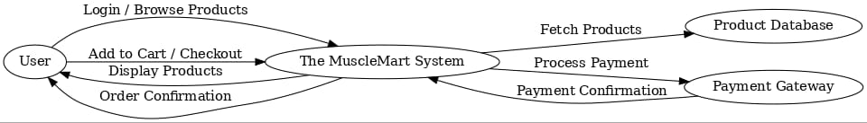

* Use case Diagram

**Testing of Software**

The Rent Anything Marketplace will undergo rigorous software testing to ensure a seamless, secure, and high-performance rental experience. The testing process includes black box testing (functional and user experience testing) and white box testing (code-level verification).

### **1. Black Box Testing**

Black box testing focuses on the external behavior of the software, without detailed knowledge of its internal code. Testers examine the application's functionality and features from a user's perspective.

**a. Functional Testing:**

* Verify that key features like user registration, login, item listing, rental process, and payment processing work as expected.

**b. Usability Testing:**

* Assess the application's user interface, design, and navigation to ensure it’s user-friendly and intuitive for customers.

**c. Security Testing:**

* Check for security vulnerabilities and ensure that user data, payment information, and rental history are protected.

**d. Performance Testing:**

* Evaluate the application's performance under various conditions, such as high user traffic and large product listings.

**e. Compatibility Testing:**

* Ensure that the application works on different browsers (e.g., Chrome, Firefox) and devices (e.g., mobile, tablet, desktop).

**f. Accessibility Testing:**

* Verify that the application is accessible to users with disabilities, ensuring compatibility with screen readers and keyboard navigation.

**g. Localization and Internationalization Testing:**

* Check if the application supports different languages, currencies, and regional formats.

### **2. White Box Testing**

White box testing involves examining the internal structure and code of the application. Testers typically need access to the source code for this type of testing.

**a. Code Review:**

* Review the code for potential issues, including coding standards, security vulnerabilities, and optimization opportunities.

**b. Unit Testing:**

* Test individual functions or modules within the code (e.g., rental request, payment processing) to ensure they work correctly.

**c. Code Coverage Testing:**

* Ensure that the code is adequately covered by test cases to maximize test effectiveness.

**d. Security Vulnerability Scanning:**

* Use static code analysis tools to identify potential security vulnerabilities like SQL injection and cross-site scripting (XSS).

**e. Database Testing:**

* Examine how the application interacts with the database, checking for data consistency, integrity, and proper data retrieval.

**f. Integration Testing:**

* Test the interaction between different components or services in the application, such as user authentication, payment processing, and rental management

LOGIC PAGE

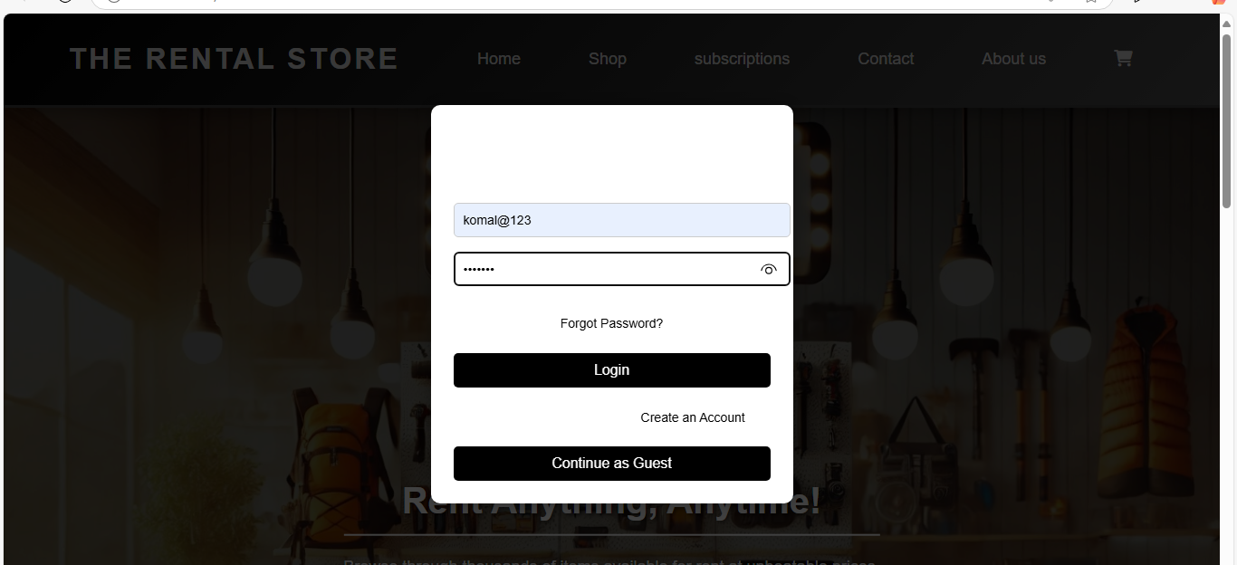

HOME PAGE



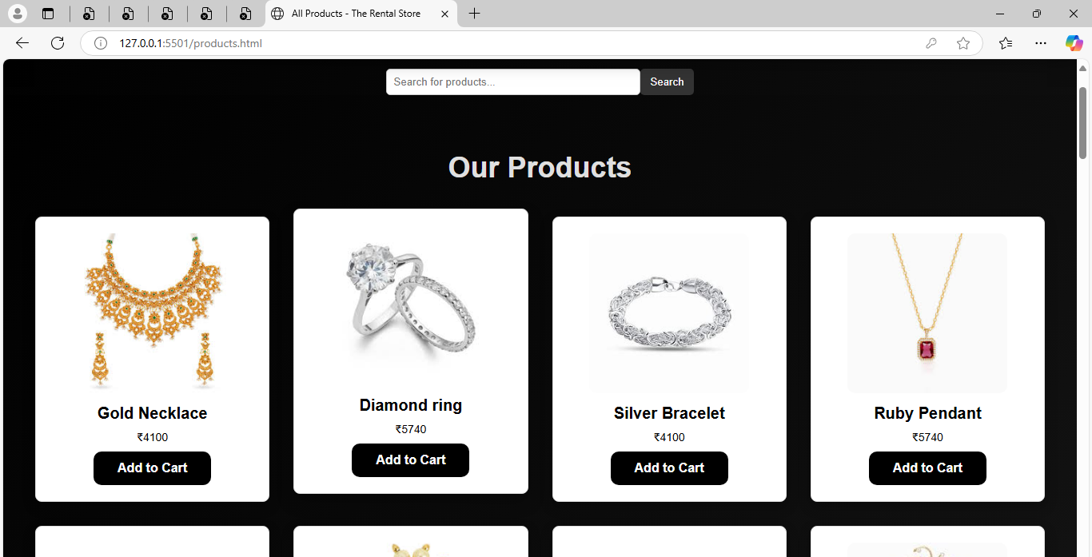EXPLORE

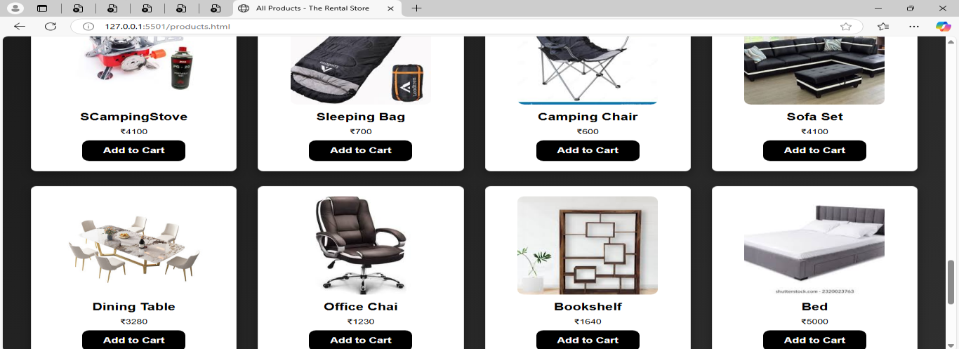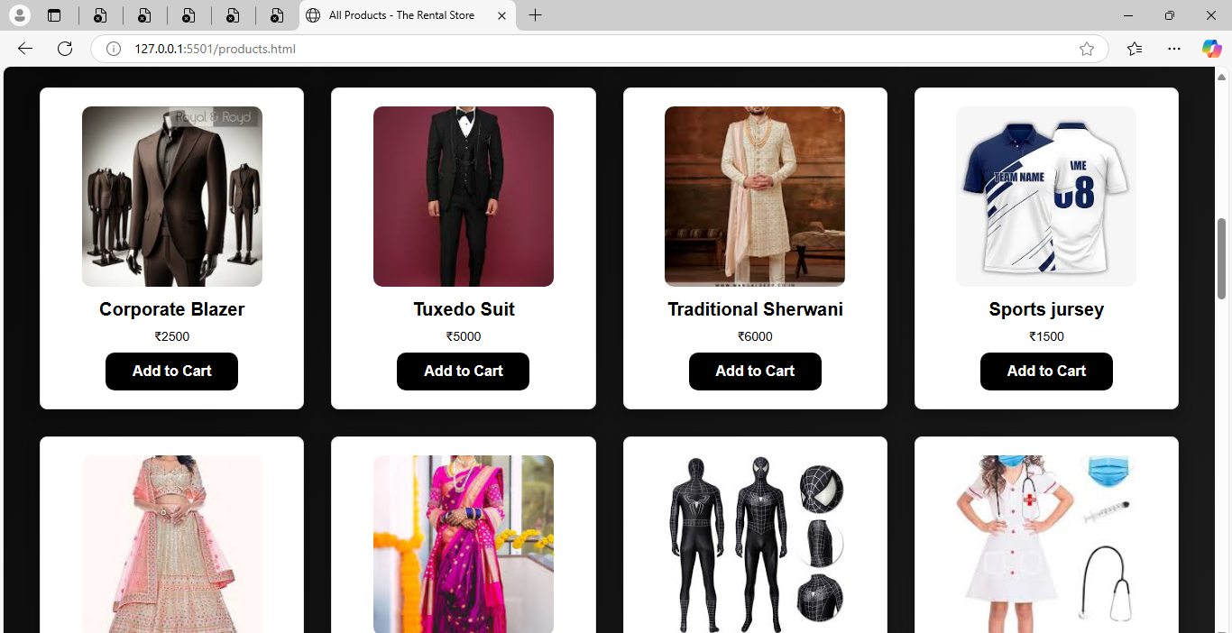

RENT BY CATEGORY(SHOP PAGE)

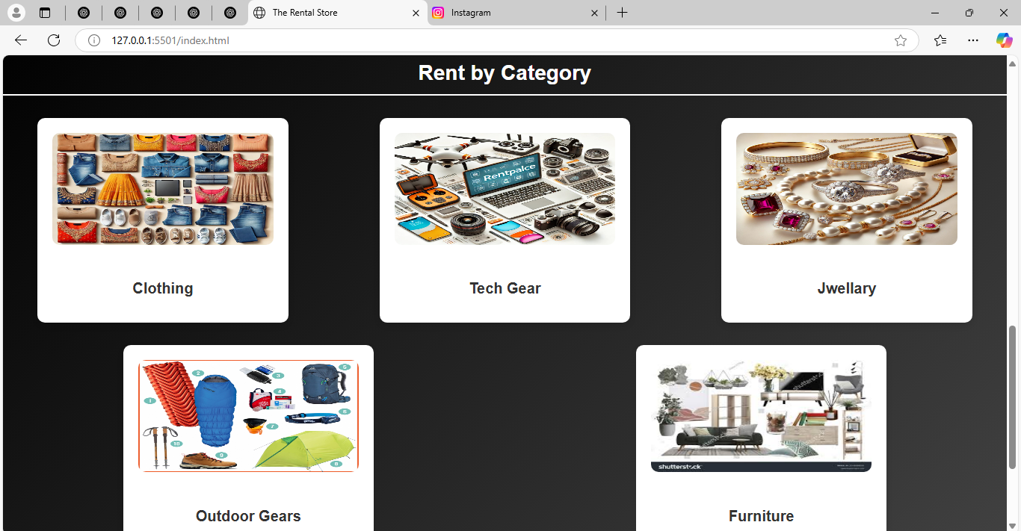

CLOTHING SECTION

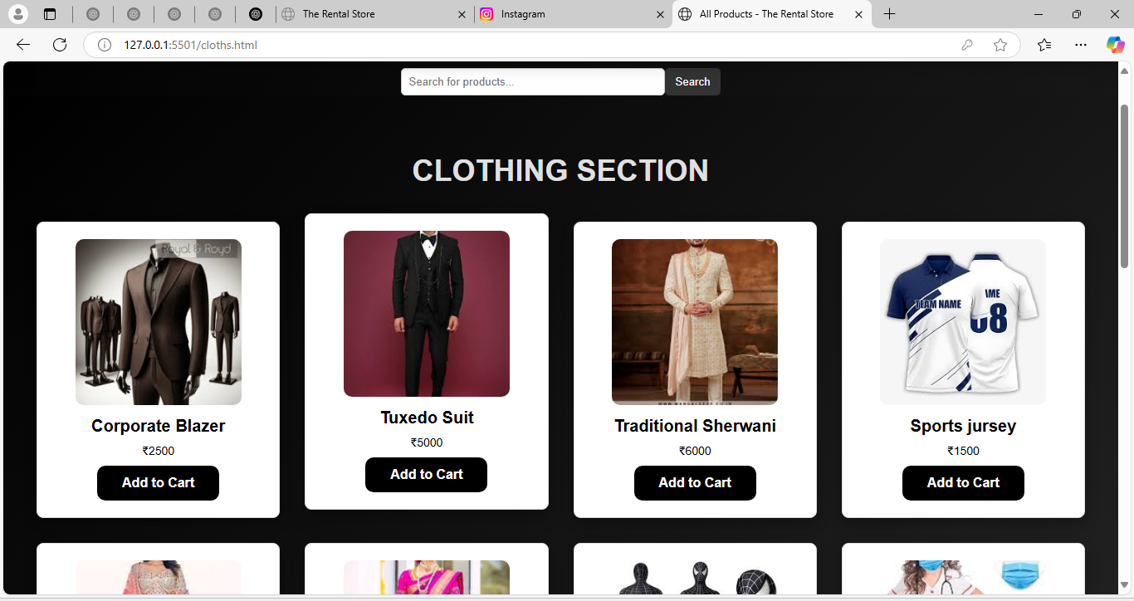

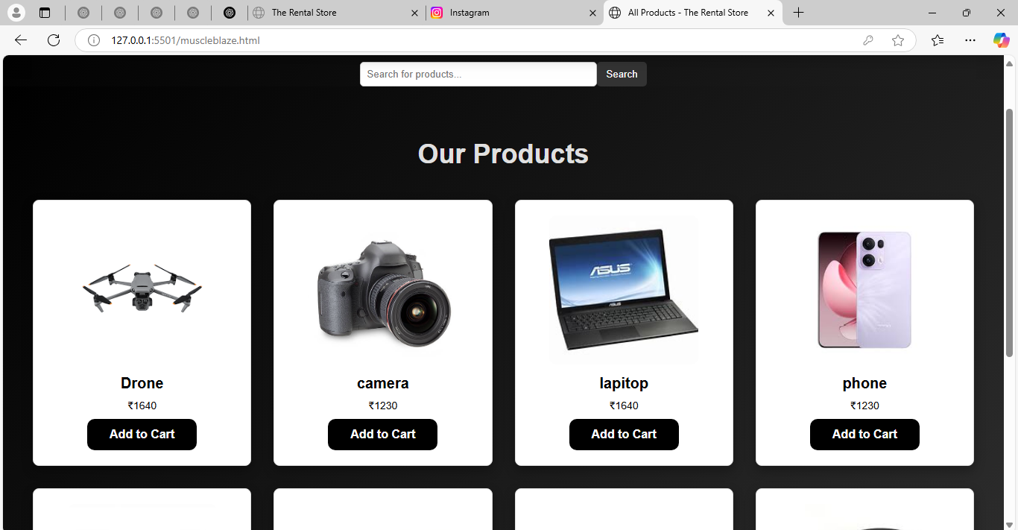TECH GEAR SECTION

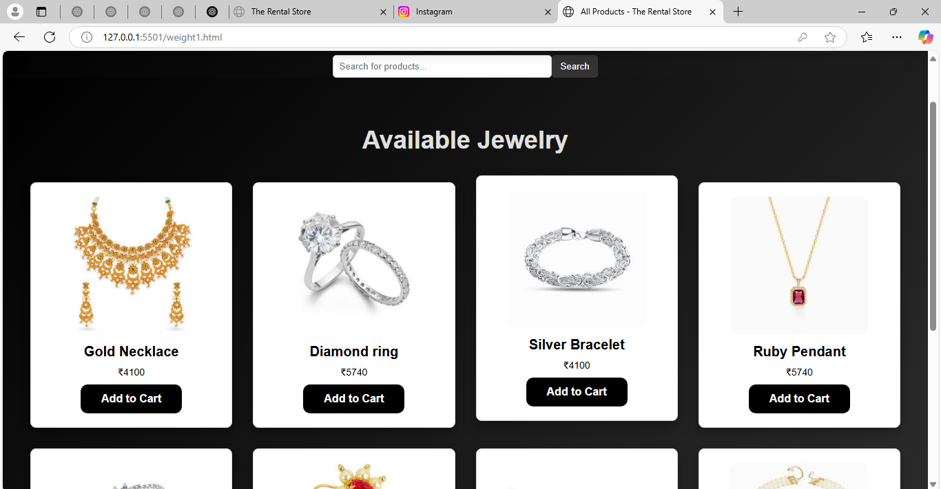JWELLARY SECTION

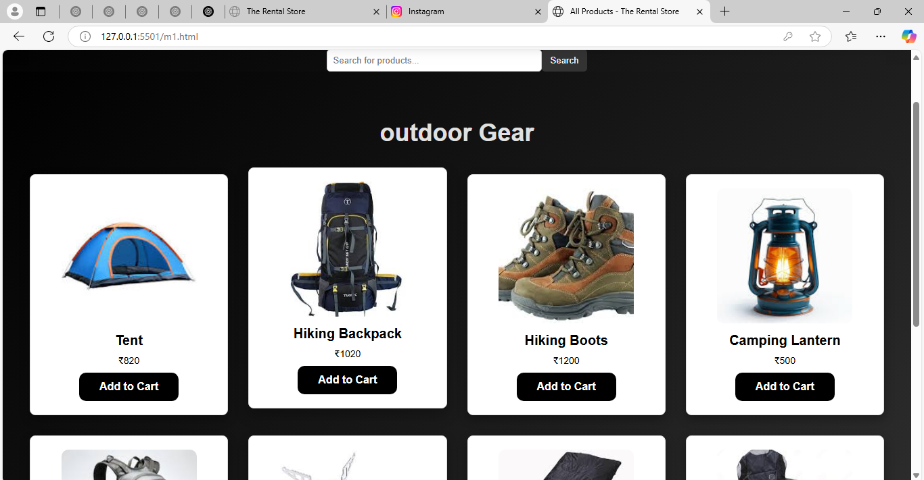OUTDOOR GEAR

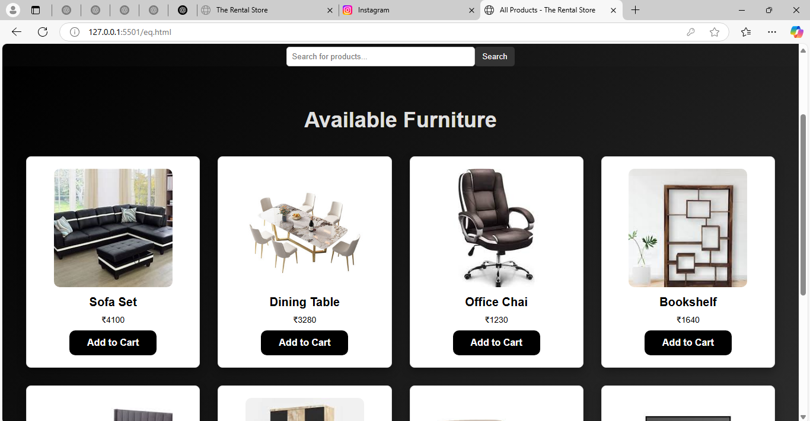FURNITURE SECTION

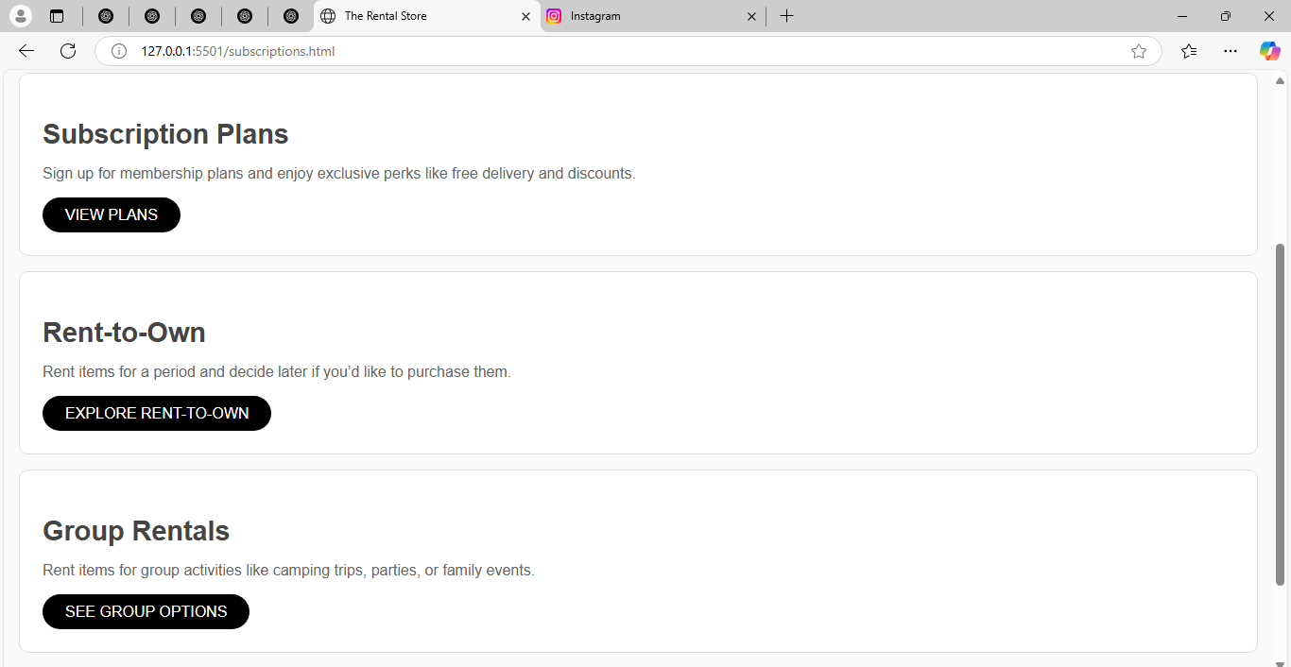SUBSCRIPTIONS

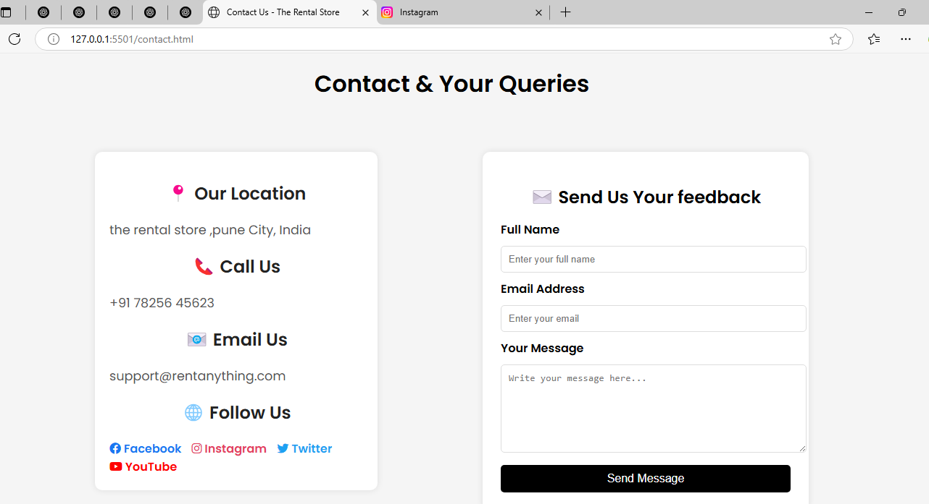CONTACT PAGE

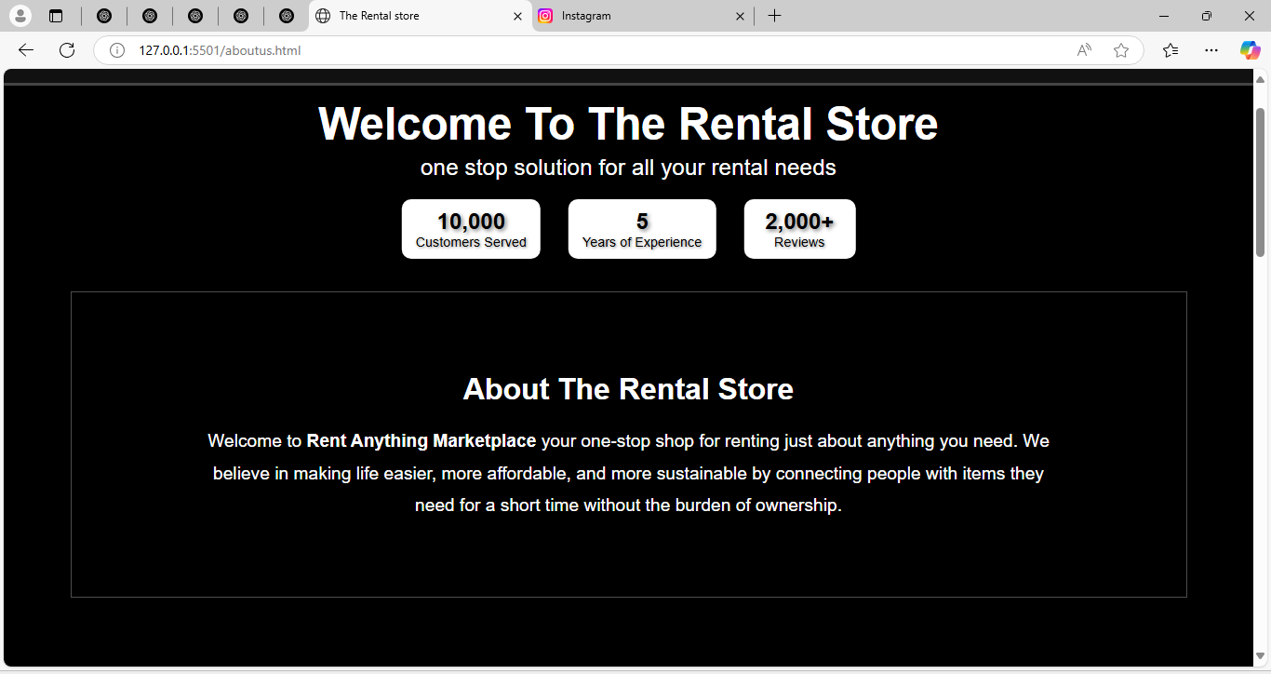ABOUT US PAGE

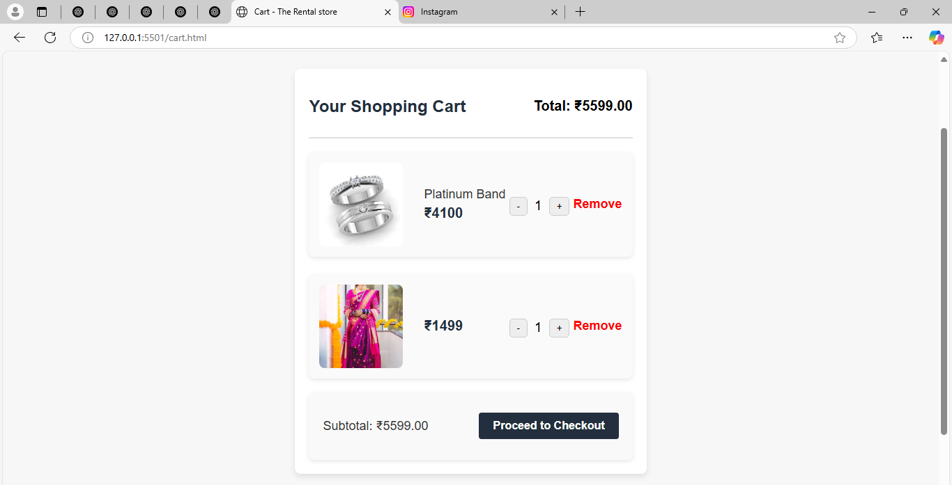CART PAGE

ORDER

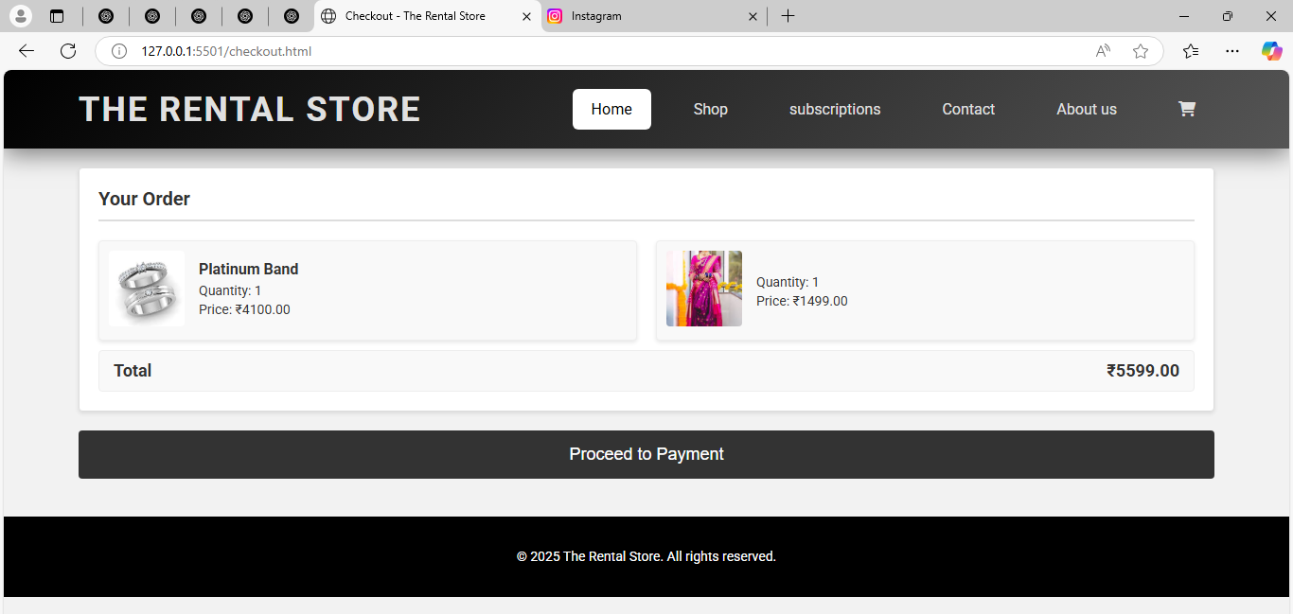

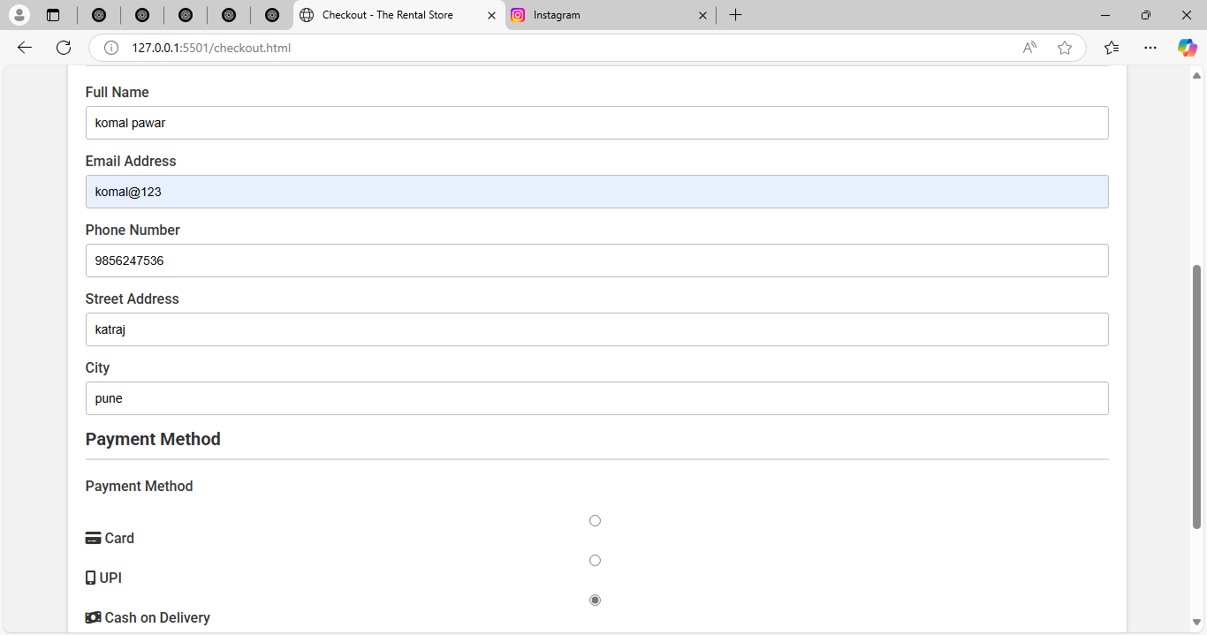SHIPPING DETAILS

PAYMENT SECTION

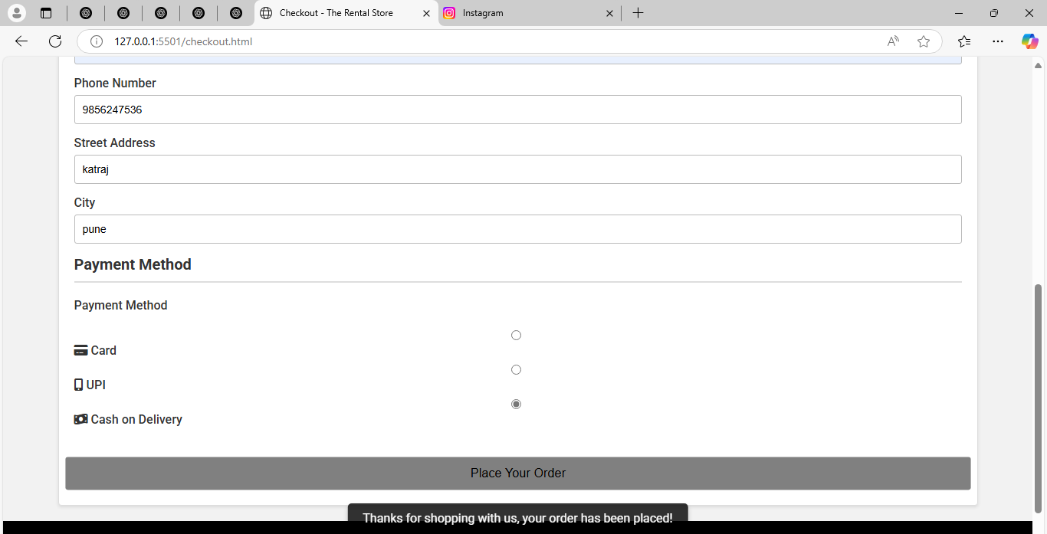

Drawback

### **1. Product Quality Variability**

* If multiple renters are listing items, maintaining consistent product quality can be challenging.
* Poorly maintained or damaged rental items can lead to negative reviews and decreased customer trust.

### **2. Item Availability Issues**

* High demand for certain rental items may lead to availability issues.
* Limited stock can frustrate customers and lead them to seek alternatives elsewhere.

### **3. Payment and Transaction Challenges**

* Technical issues with payment processing may result in failed transactions and abandoned bookings.
* Security concerns regarding online payments can deter customers from using the platform.

### **4. Fraudulent Listings and Scams**

* Fake or misleading rental listings may appear on the platform if not properly monitored.
* Customers receiving substandard or non-existent items can harm the platform’s reputation.

### **5. Booking Abandonment**

* Complicated rental processes, unclear pricing, or additional hidden fees may discourage users from completing a booking.
* A lack of flexible payment options can result in lost customers.

### **6. SEO and Market Competition**

* Competing with well-established rental platforms for visibility in search results can be challenging.
* Poor SEO strategies can result in lower organic traffic and reduced platform engagement.

### **7. Customer Service and Dispute Resolution**

* Handling rental disputes, item damage claims, and refund requests can be resource-intensive.
* Poor customer support response times can negatively impact user trust and satisfaction.

### **8. Security and Privacy Risks**

* Storing user data (such as contact details and payment information) increases the risk of cyber threats.
* A data breach could result in legal issues and loss of customer confidence in the platform.

Future Enhancement

To enhance the functionality, user engagement, and overall experience of the **Rent Anything Marketplace**, the following future enhancements can be considered:

### **1. Mobile App Development**

* Develop a **dedicated mobile application** for **iOS and Android** to provide a seamless rental experience.
* Implement **push notifications** for rental updates, new listings, and promotional offers.

### **2. AI-Based Recommendations**

* Implement a **smart recommendation system** that suggests rental items based on user preferences, browsing history, and rental behavior.
* Personalize search results to enhance customer engagement.

### **3. Advanced Search & Filtering**

* Improve search functionality by adding **auto-complete, keyword suggestions, and location-based filtering**.
* Add filters for **rental price, category, availability, and user ratings**.

### **4. Loyalty and Rewards Program**

* Introduce a **reward system** where users earn points for **frequent rentals, referrals, and reviews**.
* Allow users to redeem points for **discounted rentals or free rental periods**.

### **5. User Reviews and Ratings**

* Enable customers to leave **detailed reviews and ratings** for rented items.
* Introduce a **verified renter badge** to build trust among users.

### **6. Subscription-Based Rentals**

* Offer **subscription plans** for frequently rented items like **gadgets, tools, and furniture**.
* Provide **discounts and priority access** for long-term subscribers.

### **7. Social Media Integration**

* Allow users to **share rental listings** on social media directly from the platform.
* Enable **social media login** for faster registration and checkout.

### **8. Augmented Reality (AR) Previews**

* Implement **AR-based item previews** to help users visualize products before renting.
* Allow renters to check **size, fit, and condition** virtually.

### **9. Multi-Currency and Multi-Language Support**

* Enable **currency conversion** for international users.
* Offer **multi-language support** to cater to a diverse audience.

### **10. Enhanced Payment Options**

* Integrate additional **payment gateways** like **Google Pay, Apple Pay, and PayPal**.
* Offer **"Rent Now, Pay Later"** options to increase affordability..

Bibliography

* http://www.google.com/